**Lab Assignment 14**

**Student Id : AF0411629**

**Student Name : Chauhan Vandana Ramdayal**

**Topic : Tuples**

Q1Write a python program and iterate the given tuples Input: employee1 = ("John Doe", 101, "Human Resources", 60000) employee2 = ("Alice Smith", 102, "Marketing", 55000) employee3 = ("Bob Johnson", 103, "Engineering", 75000)

Code:

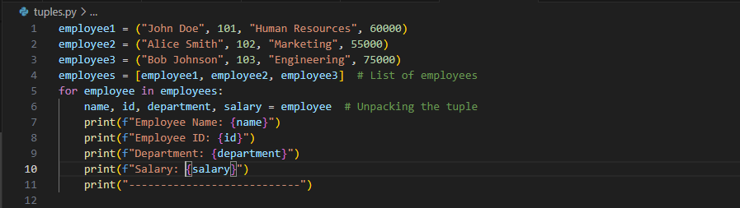

Output:

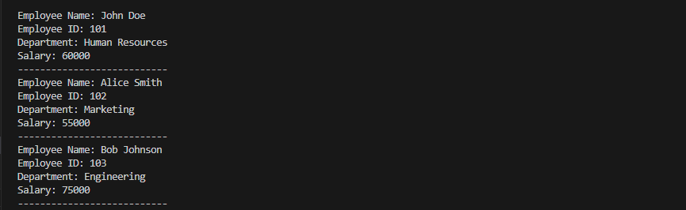

Q2.Write a Python program to convert a list to a tuple.

Input: listx = [5, 10, 7, 4, 15, 3]

 Output: (5, 10, 7, 4, 15, 3)

Code:

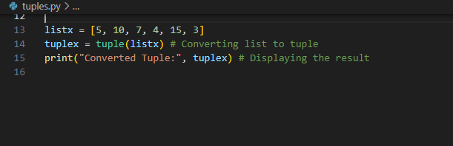

Output:

